**EXPERIMENT 1:**

**INSERTION OF VALUES**

1. **INSERTING VALUES TO BRANCH**

CREATE TABLE BRANCH (BNAME VARCHAR(20) PRIMARY KEY,CITY VARCHAR(30) CHECK (CITY IN ('NAGPUR','DELHI','BANGALORE','BOMBAY')) NOT NULL);

insert into BRANCH (bname,city)values ('VRCE' , 'NAGPUR');

insert into BRANCH (bname,city) values ('AJNI' , 'NAGPUR');

insert into BRANCH (bname,city) values ('KAROLBAGH' , 'DELHI');

insert into BRANCH (bname,city) values ('CHANDNI' , 'DELHI');

insert into BRANCH (bname,city) values ('DHARAMPETH' , 'NAGPUR');

insert into BRANCH (bname,city) values ('MG ROAD' , 'BANGAORE');

insert into BRANCH (bname,city) values ('ANDHERI' , 'BOMBAY');

insert into BRANCH (bname,city) values ('NEHRU PALACE' , 'DELHI');

insert into BRANCHS(bname,city) values ('POWAI' , 'BOMBAY');

select * from BRANCH;

**OUTPUT:**

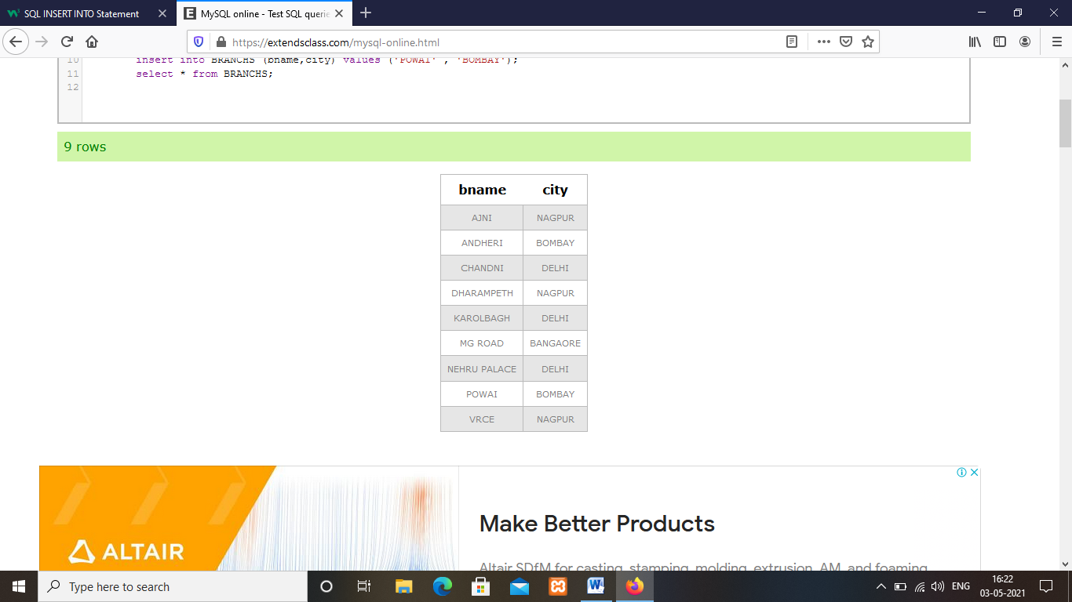

1. **INSERTING VALUES INTO CUSTOMER TABLE**

create table CUSTOMER (CNAME varchar(15),CITY varchar(20)NOT NULL,PRIMARY KEY(CNAME));

insert into CUSTOMER (CNAME,CITY) values ('ANIL' , 'CALCUTTA');

insert into CUSTOMER (CNAME,CITY) values ('SUNIL' , 'DELHI');

insert into CUSTOMER (CNAME,CITY) values ('MEHUL' , 'BARODA');

insert into CUSTOMER (CNAME,CITY) values ('MANDAR' , 'PATNA');

insert into CUSTOMER (CNAME,CITY) values ('MADHURI' , 'NAGPUR');

insert into CUSTOMER (CNAME,CITY) values ('PRAMOD' , 'NAGPUR');

insert into CUSTOMER (CNAME,CITY) values ('SANDIP' , 'SURAT');

insert into CUSTOMER (CNAME,CITY) values ('SHIVANI' , 'BOMBAY');

insert into CUSTOMER (CNAME,CITY) values ('KRANTI' , 'BOMBAY');

select * from CUSTOMER;

**OUTPUT:**

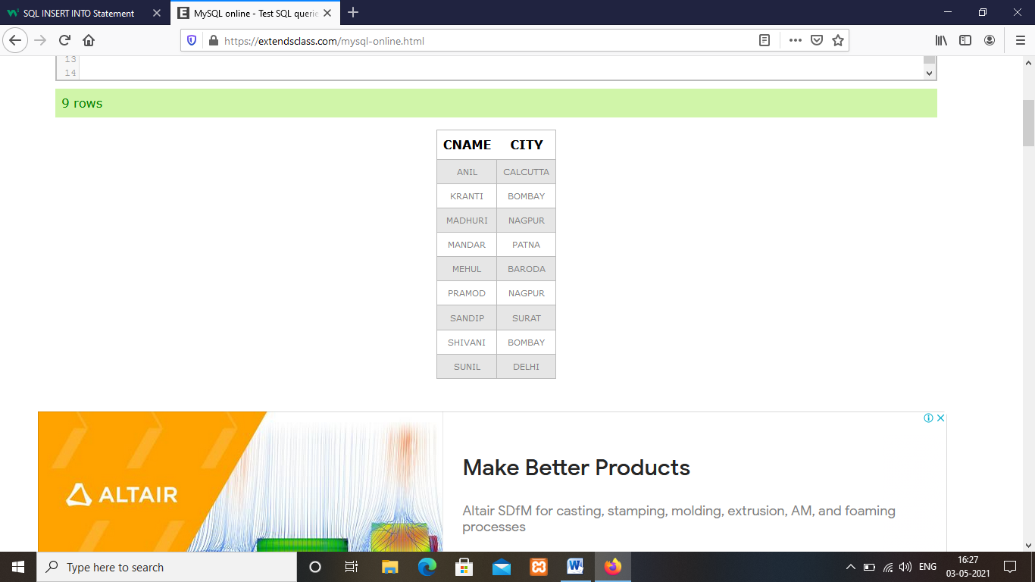

1. **INSERTING VALUES INTO DEPOSITE TABLE**

CREATE TABLE DEPOSIT (ACTNO VARCHAR(5) CHECK (ACTNO LIKE 'D%') PRIMARY KEY ,CNAME VARCHAR(15) REFERENCES CUSTOMER(CNAME) ,BNAME VARCHAR(20) REFERENCES BRANCH(BNAME),AMOUNT FLOAT(8) CHECK (AMOUNT>0) NOT NULL, ADATE DATE);

insert into DEPOSITE (ACTNO,CNAME,BNAME,AMOUNT,ADATE) values ('D100' , 'ANIL' ,'VRCE', '1000.00' ,'1-MAR-95');

insert into DEPOSITE (ACTNO,CNAME,BNAME,AMOUNT,ADATE) values ('D101' , 'SUNIL' ,'ANJNI', '500.00' ,'4-JAN-96');

insert into DEPOSITE (ACTNO,CNAME,BNAME,AMOUNT,ADATE) values ('D102' , 'MEHUL' ,'KAROLBAGH', '3500.00' ,'17-NOV-95');

insert into DEPOSITE (ACTNO,CNAME,BNAME,AMOUNT,ADATE) values ('D103' , 'MADHURI' ,'CHANDNI', '1200.00' ,'17-DEC-95');

insert into DEPOSITE (ACTNO,CNAME,BNAME,AMOUNT,ADATE) values ('D104' , 'PRAMOD' ,'MG ROAD', '3000.00' ,'27-MAR-96');

insert into DEPOSITE (ACTNO,CNAME,BNAME,AMOUNT,ADATE) values ('D105' , 'SANDIP' ,'ANDHERI', '2000.00' ,'31-MAR-96');

insert into DEPOSITE (ACTNO,CNAME,BNAME,AMOUNT,ADATE) values ('D106' , 'SHIVANI' ,'VIRAR', '1000.00' ,'5-SEP-95');

select * from DEPOSITE;

**OUTPUT:**

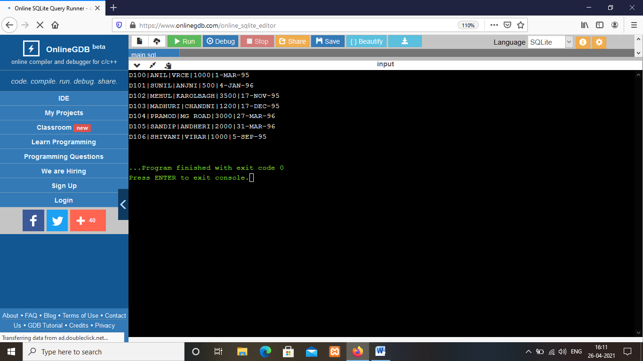

1. **INSERTING VALUES INTO BORROW TABLE**

CREATE TABLE BORROW (LOANNO VARCHAR(8) CHECK (LOANNO LIKE 'L%') PRIMARY KEY,CNAME VARCHAR(15) REFERENCES CUSTOMER(CNAME) ,BNAME VARCHAR(20) REFERENCES BRANCH(BNAME),AMOUNT FLOAT(8) CHECK (AMOUNT>0) NOT NULL);

insert into BORROW (LOANNO,CNAME,BNAME,AMOUNT) values ('L201' , 'ANIL' ,'VRCE', '1000.00');

insert into BORROW (LOANNO,CNAME,BNAME,AMOUNT) values ('L202' , 'SUNIL' ,'ANJNI', '500.00');

insert into BORROW (LOANNO,CNAME,BNAME,AMOUNT) values ('L203' , 'MEHUL' ,'KAROLBAGH', '3500.00');

insert into BORROW (ACTNO,CNAME,BNAME,AMOUNT) values ('L204' , 'MADHURI' ,'CHANDNI', '1200.00');

insert into BORROW (ACTNO,CNAME,BNAME,AMOUNT) values ('L205' , 'PRAMOD' ,'MG ROAD', '3000.00');

insert into BORROW (ACTNO,CNAME,BNAME,AMOUNT) values ('L206' , 'SANDIP' ,'ANDHERI', '2000.00');

insert into BORROW (ACTNO,CNAME,BNAME,AMOUNT) values ('L207' , 'SHIVANI' ,'VIRAR', '1000.00');

select * from BORROW;

**OUTPUT:**

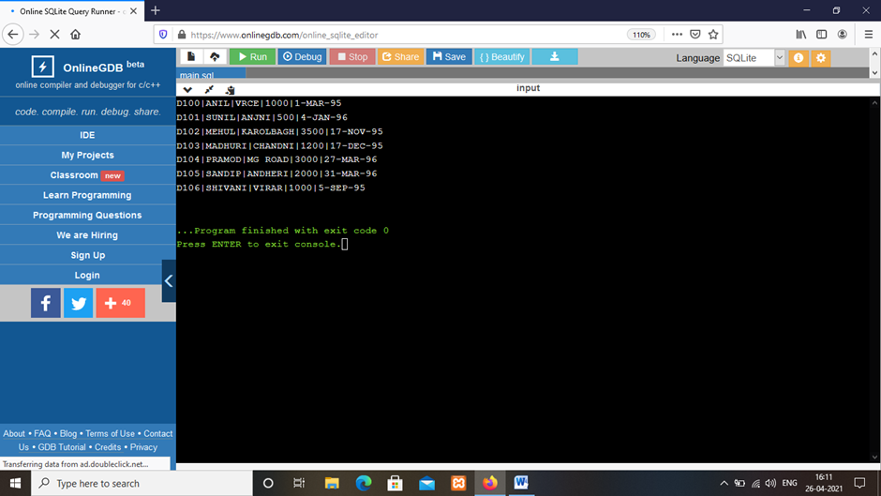

**EXPERIMENT:2**

**SELECTING DATA FROM SINGLE TABLE**

1. **List all data from table deposite**

SELECT*FROM DEPOSIT;

1. **List all data from borrow**

SELECT*FROM BORROW;

1. **List all data from customer**

SELECT*FROM CUSTOMER;

1. **List all data from branch**

SELECT*FROM BRANCH;

1. **Give account no and amount no.of deposit**

SELECT ACTNO, AMOUNT FROM DEPOSIT;

1. **Give customer name and account no of depositors**

SELECT CNAME,ACTNO FROM DEPOSIT;

1. **Give name of customers**

SELECT CNAME FROM CUSTOMER;

1. **Give name of branches**

SELECT BNAME FROM BRANCH;

1. **Give name of borrow**

SELECT CNAME FROM BORROW;

1. **Give names of customer living in city Nagpur**

SELECT CNAME FROM CUSTOMER WHERE CITY='NAGPUR';

1. **Give names of depositors having amount greater than 4000**

select CNAME from DEPOSIT where AMOUNT>4000;

1. **Give account date of Anil**

SELECT ADATE FROM DEPOSIT where CNAME='ANIL';

1. **Give name of all branches located in Bombay**

select BNAME from BRANCH where CITY='Bombay';

1. **Give name of borrower having loan number 1205**

select * from BORROW;

select CNAME from BORROW where LOANNO='L205';

1. **Give names of depositors having account at VRCE**

select CNAME from DEPOSIT WHERE BNAME='VRCE';

1. **Give names of all branched located in city Delhi**

select BNAME from BRANCH WHERE CITY='Delhi';

1. **Give name of the customers who opened account date ‘1-12-96’**

select CNAME from DEPOSIT WHERE ADATE='1996-12-1';

1. **Give account no and deposit amount of customers having account opened between dates ‘1-12-96’ and ‘1-5-96’**

select ACTNO,AMOUNT from DEPOSIT WHERE ADATE BETWEEN '1996-12-1' AND '1996-05-1';

1. **Give name of the city where branch KAROLBAGH is located**

select CITY from BRANCH where BNAME='KAROLBAGH' ;

1. **Give details of customer ANIL**

select * from customer join borrow on customer.cname=borrow.cname join deposit on deposit.cname=borrow.cname where customer.cname='ANIL';